PDA SPRING KICKOFF 2018 T-Shirt Pre-order Form
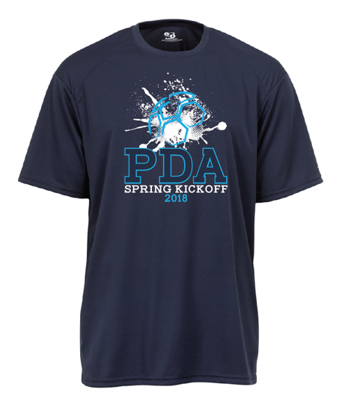
Short Sleeve Nike Logo T-Shirts - Navy Blue
Pre - order price: $18 Team orders only please!
Team orders must be picked up at the headquarters tent at the fields you are playing at by a team representative. T-shirts will also be available at the fields in limited quantities, for $20.
Please send this form with check (payable to PDA) to: PDA Spring Kickoff 23 Drakesdale Road Flanders. NJ 07836
DEADLINE for pre-orders is APRIL 8th 2018 Questions: nickheinemann@hotmail.com
Team Name:
Team Age Group:
Contact Name:
Contact Email:
Contact Phone:
 | YL | YXL | AS | AM | AL | AXL | Total # | Total $
Short Sleeve Navy

